01.06 MEL Administration
Process Design & AMOS Configuration Document
Purpose
This Process Design document is provided to Key-Users to record their key decisions regarding the AMOS Process design and the required AMOS configuration.
It is updated throughout the Project Definition Phase and used as the baseline for the Final Acceptance prior to Go-Live
Revision
Author, Name | Date | Notes
PRADEEP PATHIRANA | 29.May 2024 | 1. version

Table of Contents
1. Process Overview & Objectives 3
2. Regulatory References 3
3. Definitions & Glossary 3
4. Process Tasks 3
5. Process Dependencies 4
6. Process Flow 5
7. Process Design Questions 6
8. Data (Source) Mapping 8
9. Other Software Used 8
10. AMOS Configuration 9
a. Basic Data 9
b. Parameters 9
c. Workflows 10
d. Scheduled Tasks 11
e. API’s & Interfaces 12
11. UAT Guidance 12
12. Annex – Additional Info 12

Process Overview & Objectives

Process General Description:
The Minimum Equipment List (MEL) is a joint operations and maintenance document prepared and published by an operator to:
- Identify the minimum equipment and conditions for an aircraft to maintain the Certificate of Airworthiness in force and to meet the operating rules for the type of operation;
- Define operational procedures necessary to maintain an acceptable level of safety and to deal with inoperative equipment; and
- Define maintenance procedures necessary to maintain an acceptable level of safety and procedures necessary to secure any inoperative equipment.
Every operator has to create an MEL based on the Master Minimum Equipment List (MMEL). The operator's MEL needs to be approved by the local authority of the operator. After approval, the MEL is an approved dispatch document for flight operations and is also used by maintenance to defer defects/malfunctions.

In addition to the MEL, which describes dispatch conditions and requirements for aircraft systems, there is a second document called Configuration Deviation List (CDL). The CDL describes the allowed missing part configuration of an aircraft (e.g. missing panels, static discharges, etc.)

Main Process Objective:
The integrated MEL Administration process within AMOS enables the operator, or CAMO, to digitally create their MEL/CDL.
The creation process offers complete flexibility, enabling manual creation as well as the import of structured data (XML, SGML), as detailed in Process 02.05 of the Technical Library, or migration utilizing X-Files.
Either the operator can use the MMEL from the OEM to create their own MEL, or they can import an already finalized and approved MEL from a 3rd party IT system, which AMOS only uses for follow-up processes.

References

Definitions & Glossary

Key-Words | Explanation
MEL | Minimum Equipment List
MMEL | Master Minimum Equipment List
CDL | Configuration Deviation List
NEF | Non-essential Equipment and Furnishings

Process Tasks

Business Process Task / Actions / Activities :
- Creating MEL/ CDL Book in AMOS
- Update, Edite, and Revision the MEL/CDL Book
- Defer the maintenance event according to MEL/ CDL in AMOSdesktop
- Defer the maintenance event according to MEL/ CDL in AMOSmobile
- Track, control, analyse and report MEL Usage

Process Dependencies

- 01.01 Aircraft Definition
- 02.05 Technical Library

Process Flow
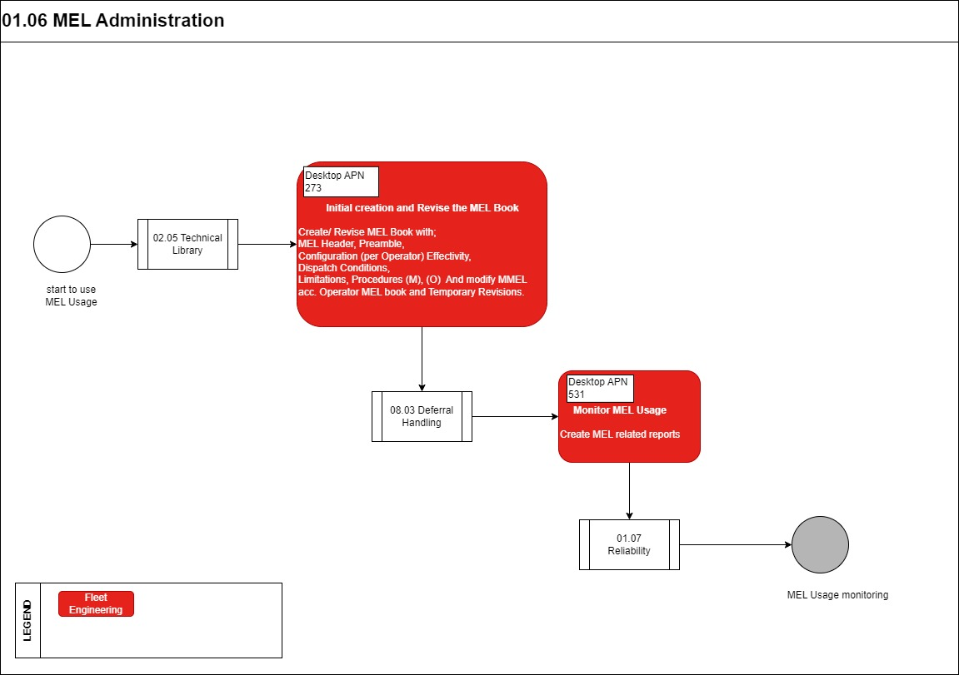

Process Design Questions

# | Question | Answer
Q1 | Who is responsible for creating the MEL within the organization?
Q2 | Is a 3rd party IT system used to create the MEL/CDL?
Q3 | Is the 3rd party IT system able to export MEL/CDL as XML?
Q4 | What is the publication process for the MEL within the organization?
Q5 | Are there any tools within your company to access the approved MEL / CDL?
Q6 | Who needs access to MEL / CDL within the CAMO / MRO departments/organization?

Data (Source) Mapping

Data Sources | Description | Volume / Manual / Automatic / Static / Dynamic
MMEL | Master Minimum Equipment List (MMEL) which is provided by OEM

Other Software Used

Other Softwares | Used by: | Description

AMOS Configuration

Add comments about the AMOS Configuration

Basic Data

Basic Data Table | Notes
NIL

Parameters

Parameter Code | Parameter Name | Notes
1363 | FREE MEL EDIT (ALLOW UNKNOWN MEL/CDL/NEF REFERENCES) | DO NOT CHECK MEL/CDL/NEF FIELD
1847 | Display options for the MEL Item Dispatch panel in MEL Manual Administration (ATA chapter level) and Workorder Transfer | This parameter activates the restriction
1924 | Handling of Effectivities for MEL Items and Dispatch Conditions
1929 | Display the Dispatch Conditions before the sub-items in the MEL tree

Workflows

Workflow Number | Workflow Name | Notes
33 (desktop) / 406 (mobile) | Workorder closed (post-save) | This workflow is triggered when a workorder is closed.  This workflow will be able to track the deferred workorders (MEL, CDL, NEF, etc.) when they are closed.
100 (desktop) / 405 (mobile) | Workorder saved (post-save) | This workflow is triggered when saving a workorder.  This workflow will be able to track the deferred workorders (MEL, CDL, NEF, etc.) when they are saved.

API’s & Interfaces

Reference / Interface | Trigger
EXPORT MEL BOOK | Exports the content of the MEL book defined in AMOS, including:  - revision information  - detailed item description  - dispatch conditions  - procedures  - effectivities

UAT Guidance

UAT No | Proposed User Acceptance Test Scenario
01.06.1 | MEL Administration - Create a MEL Book
01.06.2 | MEL Administration- Create a new revision of the MEL book
01.06.3 | MEL Administration- Add MEL item (including dispatch conditions, and limitations)

Annex – Additional Info

